PILGRIM

GAMES AND ACTIVITIES

TEXAS MAYFLOWER SOCIETY
EDUCATION
Sandra Sauers, Chair

OBJECTIVE:
Interaction with groups to teach and learn the games and activities that were played by the Pilgrims and how the games adapted and changed over time.

USE:
For Mayflower meetings, classrooms, home school educators and families.

MATERIALS:
Game pages will list various materials required for the games. i.e. small tree twigs, small rocks, clay marbles, twine, wood buttons, etc.

GOAL:
Provide the participants a look into the history of the games and activities that were available for the Pilgrim, men, women and children and how to create these games and activities.

LIST OF GAMES:
All Hid (Hide and Seek)
Clay Marbles
Draughts
Hopfrog or leapfrog
Hubbub
Jacob’s Ladder
Knickers (marbles)
Knicker Box
Maze
Naught and Crosses (tic tac toe)
Ninepins
Nine Men Morris
Pitching the Bar
Puzzles and Riddles or Tongue Twisters
Relay or Foot Races
Spinning Wooden Tops
Stool Ball
Word Search Game

HISTORY OF GAMES
“The first traces of a game invented by humans were discovered in Europe and refer to the Bronze Age (Chalcolithic period) nearly 7000 years ago. However, nothing had been found about the rules or the way the game is played.”
“In the Persian Gulf, we discovered the oldest game in the world: “The royal game of Ur”.
“The Assyrians invented this game more than 5000 years ago. It was a board game, with a board representing a course and pieces that players were moving. This game is preserved in a museum in London.” 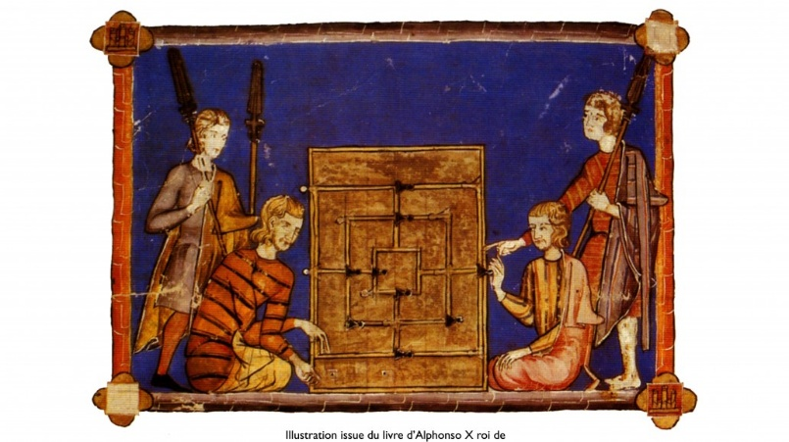
“Archaeologists have also found evidence (paintings and frescoes) of puzzle games in Egypt and in the Babylonian civilization. During the ancient Greek period many games were invented, but no trace of games with coins was found. On the other hand, Roman games came to the surface, and they maybe were identical to Greek games.”
“In Europe during the middle Age, there were mainly games of skill and outdoor games. But the relevant sources are not verified. In 1280 the king of Castile and Leon, “Alfonso X the Wise,” wrote “The Book of Games”, a collection of many games such as Chess or Alqueque.”
“Various books were written over the centuries; an encyclopedia was published in France in 1888. The entire population played games, but some (cards, chess) were reserved for the bourgeoisie.”
“It was during the industrial revolution, around 1850, that the game known today as checkers or the game of goose spread. In 1980, the game industry experienced revival in the West. Today, the game family of checkers is enormous and there are hundreds of games and even more variations around the world.” https://www.kaloumba.com/en/history-of-games/

PILGRIM GAMES
ALL HID
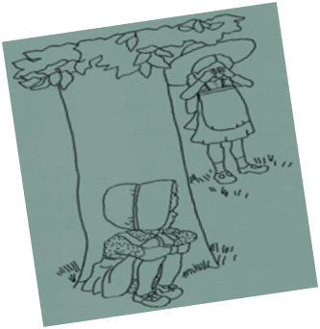
Al Hid is now known as Hide and Seek.
CLAY MARBLE
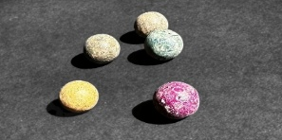
Recipe for making clay marbles:
Combine 3 cups of salt with 1 cup of water in a medium saucepan over medium heat.
Add 1 cup of cornstarch gradually a tablespoon at a time, stirring well after every addition.
Stir the mixture continuously until it thickens, becomes a sticky mass and pulls away from the pot.
Spoon the mass of cornstarch clay onto a sheet of aluminum foil. Allow it to cool to the point that it can be handled comfortably.
Knead the mass until it is stiff dough that is no longer sticky.
Break off small pieces of the dough and form them into marbles; roll them in your hands until they are ball shaped.
Set the marbles on a dish on the counter to dry for 24 to 48 hours.
The marbles will have a smooth, hard finish suitable for painting.

COBB’S CASTLE
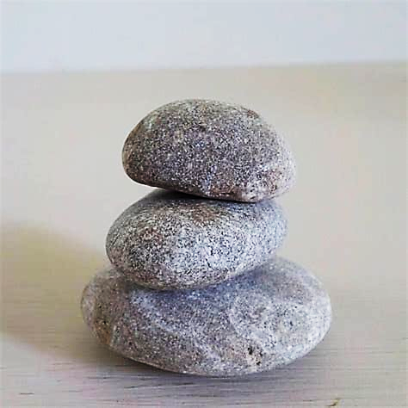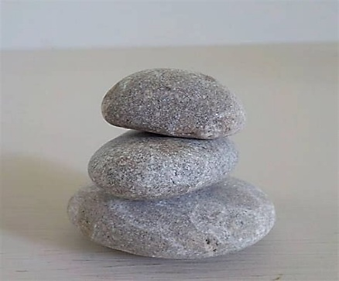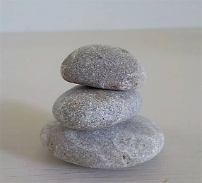
Place three (3) large stones close together on the ground. That is the “cobb”. Place another stone on top. That is the “castle”. Step back and toss stones at the castle to try to knock it down. First to do knock the castle down wins.

CUP AND BALL
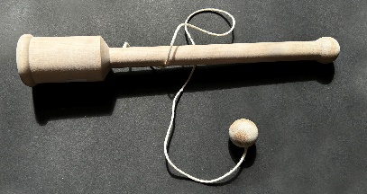
The Cup and Ball has long been a favorite toy, once consisting of wood, a clay ball and a piece of string. The goal is to catch the ball into the cup.

DRAUGHTS
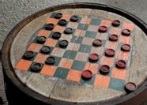

Draughts are now known as checkers. Pilgrims used wooden buttons or wood pieces. It was played with similar rules to modern day checkers.

HOOP ROLLING
Photo of hoop and stick
Hoop rolling has been documented since antiquity in Africa, Asia and Europe. Played as a target game, it is an ancient tradition widely dispersed among different societies. In Asia, the earliest records date from Ancient China, and in Europe from Ancient Greece. https://en.wikipedia.org/wiki/Main_Page
In the Americas, it has been played by a great number of unrelated Native American tribes. The game has exhibited many variations of materials and size of implements and rules of play. Andrew McFarland Davis Indian Games. pp. 44–56. ISBN 1595406042.
Pilgrim children would have played hoop rolling in England and would have adapted the game to their new home in America.
HOPFROG
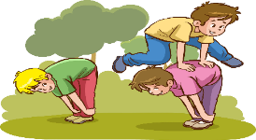
Hop frog is known today as leapfrog. This was a popular game for Pilgrim children.

HUBBUB
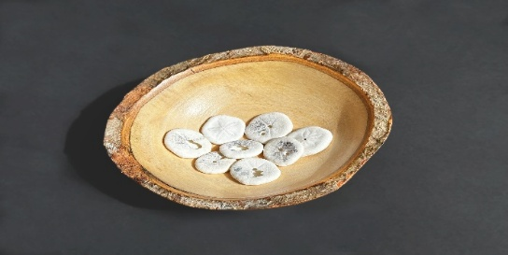
This game was played by the Wampanoag Indian children but was most likely played by the Pilgrim children as well. It is like the modern game “heads or tails” when you flip a coin. In sports the referee will toss a coin to see which team goes first. The Wampanoag game has kids bounce a bowl full of flat playing pieces, dark on one side, light on the other, onto the ground. Demonstrate the game by taking a wooden bowl and placing some coins in it, such as pennies. A player chooses a side of the coin (heads or tails) and each time the player’s side lands up during his turn, he earns a point
JACOB’S LADDER
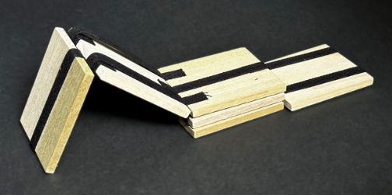
The Pilgrim played with this toy which was named after the Biblical Jacob’s Ladder described in the bible (see Genesis (28:12).
Directions: Grasp the last block of the toy by the edges of your fingertips. Tilt the block in the direction it will bend until it touches the second block. This action will set the ladder in motion, and the blocks will appear to tumble down, one after the other. To keep the action going, tip the end block back and forth.
Mystery Trick: Place a folded dollar bill behind the tape of one of the blocks. As the ladder is set in motion, the dollar bill will disappear and then reappear on the next tumble. Reference: Homestead Toys, Games and Crafts.

KEEP AWAY
Photo

Keep Away is played by drawing a circle on the ground about ten feet in diameter. One person stands in the center (and is called “it”, the monkey, the piggy, or the pickle) and the rest stand outside the circle. A player outside the circle must then throw the ball through the circle to another person outside the circle with the goal being to prevent the person who is “it” from getting to the ball. This continues until the person who is “it” catches the ball or otherwise gains possession due to a failed catch, deflection, etc. An intended recipient who fails to catch the ball replaces the person in the middle, unless they fail before the ball touches any part of their body. The ball cannot be torn out of any of the player's hands. This game was and is played throughout the world. Children who would have played this in the United Kingdom called it “Piggy in the Middle”. In the Nederlands the Dutch name for the game was "Lummelen" or "Aap in het Midden" which is “Monkey in the Middle”. https://kids.kiddle.co/

KNICKERS
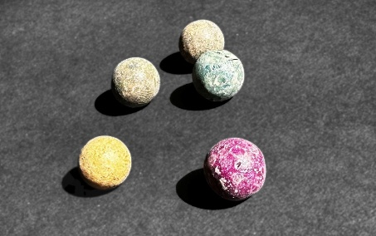
Knickers is an earlier name for what has become known as marbles. The name comes from the old Dutch term “knikker”, meaning marble or any other game played with marbles. The Pilgrim marbles would have been made from clay or could have been smooth pebbles. See Sources for Clay Recipe.

KNICKER BOX
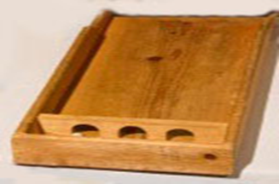
Knicker Box was a game of skill where the participant tried to control a marble rolling through a wooden box. The box involves getting through a maze of arches without it rolling back through the one it just passed through. A modern version might be the pinball machine in which the participant tries to get the ball through a series of obstacles.

NAUGHTS AND CROSSES
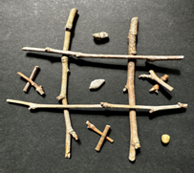
The modern version is called tic tac toe. Naught is the 0’s and Crosses are X’s.
Pilgrims as well as the Wampanoag Indians played this game. It consisted of small twigs and small rocks or drawing lines in the dirt and using the twigs for X and small rocks for 0.

NINE MEN’S MORRIS
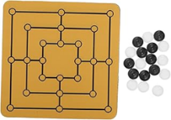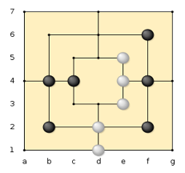
Players start out with 9 tokens (buttons, pebbles, beans, etc.)
To begin each player must take it in turns to place all of their tokens on the wooden board.
Once all the tokens are on the board, players take turns to move their tokens.
. A token can be moved from one dot to another along the lines.
. A token can only be moved 1 place at a time.
. A token cannot be moved onto a dot that is already occupied by another token.
Whenever a player forms a mill (three tokens in a row) that player can take one of their opponent’s tokens off the board (as long as it does not form a part of a mill itself).
. If all the opponent’s tokens are inside a mill, then an exception is made, and the player can take any token. The game is won when your opponent cannot move their tokens or if they have only 2 tokens left.
QUOITS
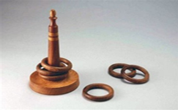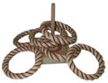
The object is to get as many rings as possible over the stick, post or pole to be the winner. Set distances are used and are like tossing a horseshoe to a post. Pilgrims would have made grass or possibly hemp rings which they threw to a stick in the ground. Mythology states that the ancient Greek God Apollo played this game. https://www.greeklegendsandmyths.com/hyacinth.html
Rules for tabletop Quoits:
1. Toss a coin to determine the order of play.
2. Place the stake (or hob) on a flat surface approximately three feet from the tossing line.
3. The first player tosses two quoits (rings) from behind the tossing line, aiming at the hob. The second player then follows with two tosses. Note —Each toss must be under-handed.)
Scoring
1. Each time a player "rings" the hob, score three points.
(This is called a ringer.)
2. If the ring just touches the hob or base, it is called a leaner and is worth two points.
3. If a player's quoit is closer to the hob than his opponent's, one point is scored.
4. First player to score 21 points is the winner!
http://www.historicalfolktoys.com/

SKIP ROPE
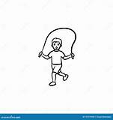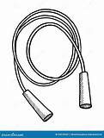
Today this is called Jump Rope, and it would have been done while chanting silly rhymes, just as children do now. History tells us that Skip Rope would have been a boy’s game as girls were not allowed to show their ankles.
Some chants:

SPINNING WOODEN TOP
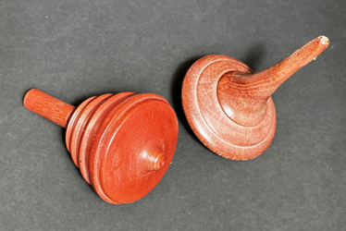
Colonial children played with wooden spinning tops. The goal was to see who could make the wooden top spin the longest. Wooden tops were carved by the Pilgrims. This toy continues to be used throughout the centuries.

STOOL BALL
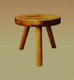 photo of wooden bat and leather ball
Children and Parents would play this game, which In modern times became baseball. The ball would be thrown at the three legged stool to knock it over and a player with a bat would attempt to hit the ball so that it did not tip the stool over.

TABLETOP NINEPINS
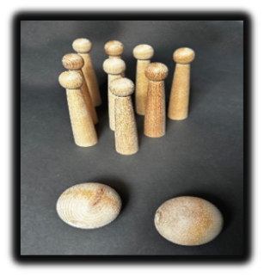
The game of Ninepins was played throughout the North American Colonies as early as 1636. A story was told that a young William Ward of Virginia received a reprimand for testing his skill at ninepins instead of watching the cows (courtesy of the Cooperman Company, Bellows Falls, VT).
Rules of Play: Can be played with 2 or more players. The object is to knock down as many of the wooden pins as possible with each roll of the ball. The first player to score 31 points is the winner. The ninepins are set up on a table or on a mark on the floor in 3 rows to form a diamond shape. A mark is set where the players will stand when rolling the ball. Each player bowls both balls, tallies the score, replaces the pins and gives the balls along to the next player. A winner is announced when they have reached 31 points.
This game has evolved into many games, such as skittles, duckpins, lawn bowls, bocce, petanque and tenpins. We now call the indoor game “bowling”.
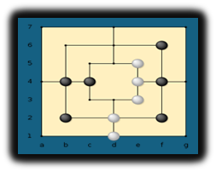

NINE MEN’S MORRIS GAME (PRINT OFF RULES AND PLAYER SHEET)
Rules of the Game For 2 Players
Each player starts with 9 tokens (pebbles, beans, buttons)
To begin each player must take it in turns to place all their tokens on the board.
Once all the tokens are on the board, players take it in turns to move their tokens:
o A token can be moved from one dot to another along the lines. o A token can only be moved 1 place at a time.
o A token cannot be moved onto a dot that is already occupied by another token.
Whenever a player forms a mill (three tokens in a row) that player can take one of their opponent's tokens off the board (as long as it doesn't form part of a mill itself).
o If all the opponent's tokens are inside a mill then an exception is made and the player can take any token.
The game is won when your opponent cannot move their tokens or if they have only 2 tokens left.

NINE MEN’S MORRIS GAME PAGE (Print Page on Heavy Cardstock)

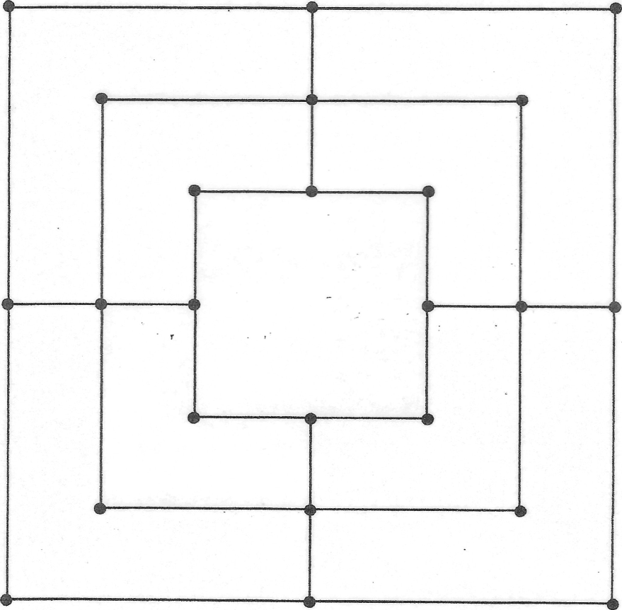

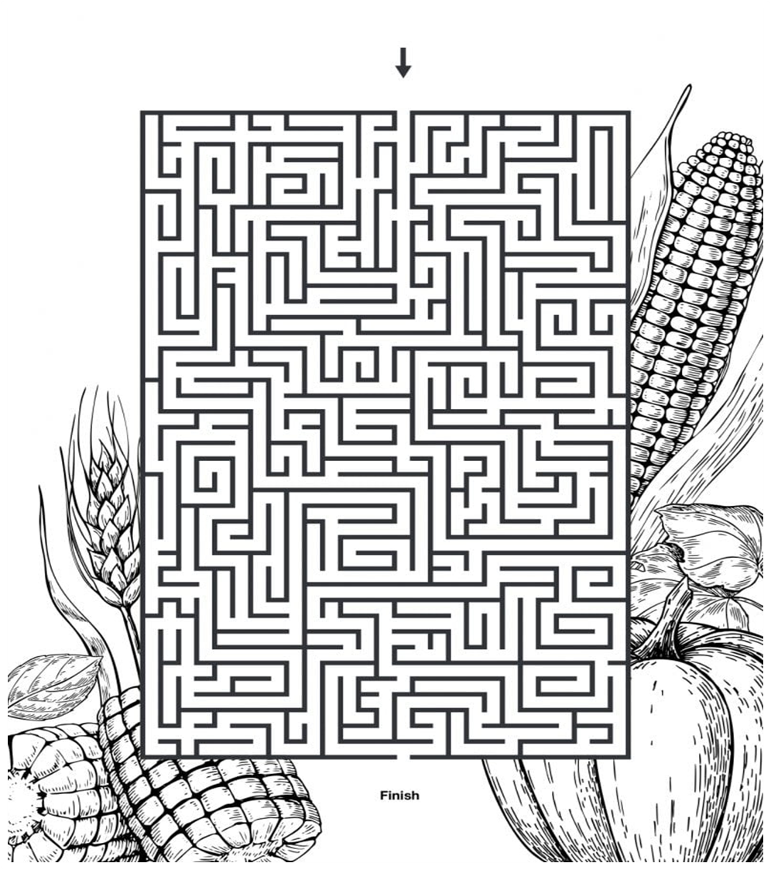

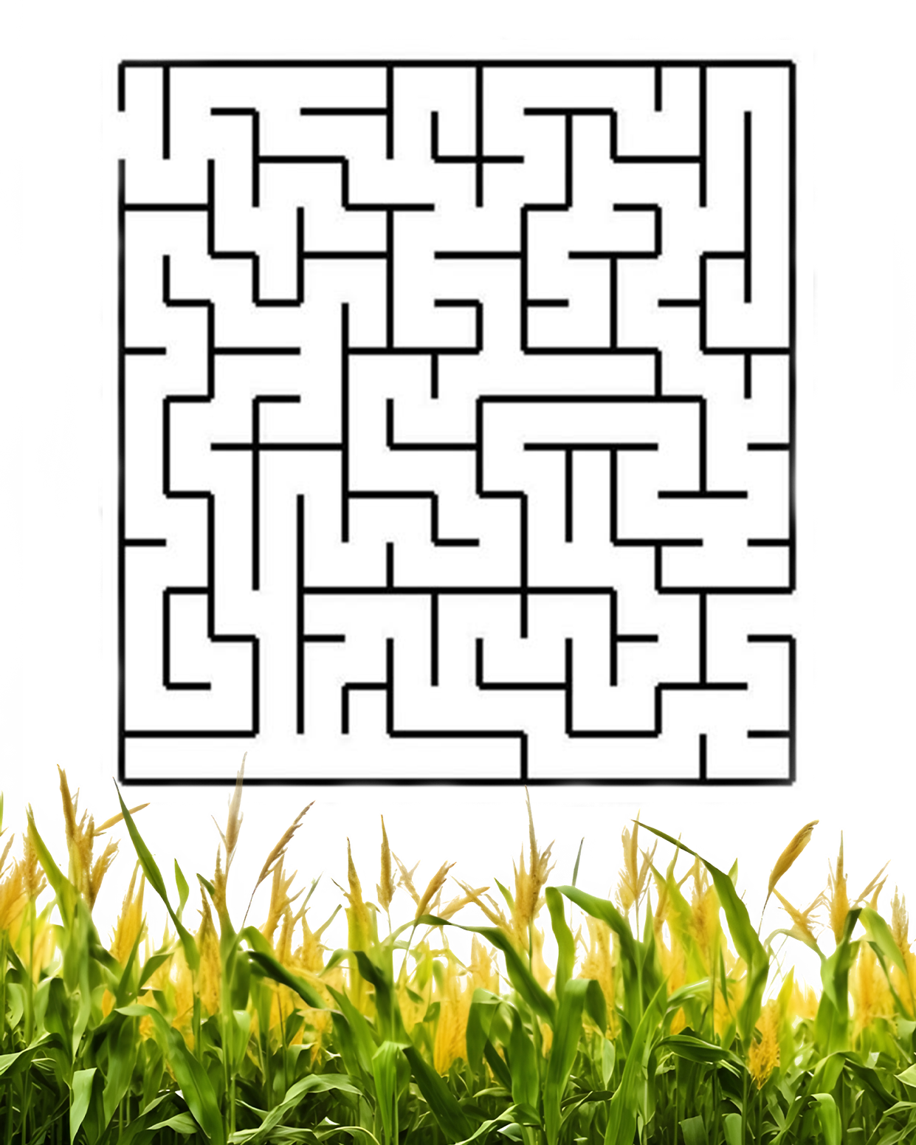
CORN MAZE

SOURCES AND REFERENCES:

https://www.homesteadtoys.com/FINAL 25 HFT Catalog4.pdf contact them to see if I can put them onto my lesson plan as a source to purchase items. Ask if I can showcase a few of what they offer
https://www.vecteezy.com/vector-art/36277345-vector-illustration-of-children-playing-leapfrog
http://www.historicalfolktoys.com/
https://www.greeklegendsandmyths.com/hyacinth.html
https://kids.kiddle.co/
https://en.wikipedia.org/wiki/Main_Page
. Andrew McFarland Davis Indian Games. pp. 44–56. ISBN 1595406042.

